Response to Rent Increase Proposal for 2019/2020 | 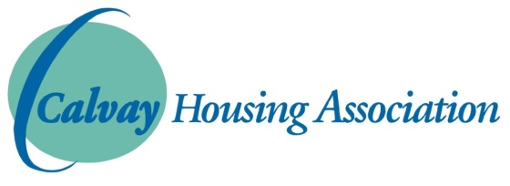

The Association seeks to provide the best possible services and investment to meet our tenants’ expectations while keeping rents as low as realistically possible. We are also working towards harmonising rents for all properties across our stock. Please give us your views on our intended rent increase for 2019/2020.

Please tick the box below which is closest to your view:-

□ I agree with the Association’s proposal to increase rents by 2.9%

□ I support a higher rent increase of 3.4% to increase the money spent on planned investment.

□ I understand some rents need to go up a bit more to bring them into line with similar properties and agree with the proposed 5%

□ I disagree with the proposed rent increase. (Please tell us why)
…………………………………………………………………………………………………………………………
…………………………………………………………………………………………………………………………
…………………………………………………………………………………………………………………………
…………………………………………………………………………………………………………………………

Name:………………………………………………………………………………..
Address:……………………………………………………………………………
Daytime Telephone Number ………………………………………..
Email:…………………………………………………………………………………

□ I want to make an appointment with the Welfare Rights Officer

Please complete and return this survey no later than Friday 18th January 2019. You can complete the form on our website www.calvay.org.uk and email back to enquiries@calvay.org.uk or phone us on 771 7722, or call into the office and speak to a member of staff. THANK YOU.

