Consultation for ex GHA Tenants and Factored Owners on Common Area Maintenance | 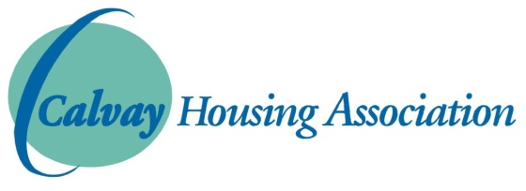

There are various bits of common land throughout the EX GHA areas that are currently maintained by the Council. Over the years, the level of maintenance has reduced substantially which has led to complaints from many of our tenants and factored owners. However, Calvay has no jurisdiction over this, while GCC own the land and retain responsibility for maintaining it.

GCC have approached all HAs in Glasgow asking them to take over these common areas of land and maintain them. Calvay HA would be willing to do this, but it would clearly cost us more money and we would need to pass on a small charge to our factored owners. The estimated cost would be around £12,000 per year, which would be approx. £33.24 for factored owners, i.e. only £8.31 per quarter.

Please tick the box below which is closest to your view:-

□ I support Calvay HA’s proposal to maintain the ex-GHA common areas

□ I would be willing to pay the small charge for this service (for factored owners only)

□ I disagree with Calvay’s proposal and think the maintenance of these areas should remain with the Council.

Any Comments…………………………………………………………………………………………………………………
……………………………………………………………………………………………………………………………………………
……………………………………………………………………………………………………………………………………………
……………………………………………………………………………………………………………………………………………

Name:………………………………………………………………………………..
Address:……………………………………………………………………………
Daytime Telephone Number ………………………………………..
Email:…………………………………………………………………………………

Please complete and return this survey no later than Friday 18th January 2019. You can complete the form on our website www.calvay.org.uk and email back to enquiries@calvay.org.uk or phone us on 771 7722, or call into the office and speak to a member of staff. THANK YOU.

